Market Data Analysis, VaR, and Option Pricing in Python

Name: Bathini Santhosh
Role: Data Engineer
Tools: Python, Numpy, Pandas, Scipy, Visual Studio
Date: 05/05/2026

1. Project Overview
This document presents a comprehensive Python-based market data analytics initiative focused on quantitative risk and valuation models. The project evaluates a SPOT portfolio using real or simulated market data and demonstrates end‑to‑end market data analysis workflows. Emphasis is placed on clarity, structure, and reproducibility to reflect production-quality standards.
2. Portfolio Valuation and Risk Analysis
The project explains SPOT portfolio valuation through price aggregation, position weighting, and time-series alignment. It includes a detailed implementation of Value at Risk (VaR) to measure downside risk. Both historical and parametric VaR methodologies are applied and compared to provide robust risk insights.
3. Option Pricing Framework
Option pricing is implemented using the Black–Scholes model. Core inputs such as volatility, risk-free interest rate, and time to maturity are explicitly modeled. The calculated option prices are validated against theoretical expectations and financial intuition to ensure accuracy.
4. Code Design, Testing, and Reproducibility
The codebase is organized into modular, reusable components to improve maintainability and readability. Unit tests are included to validate financial calculations and handle edge cases. The project emphasizes reproducibility through documented assumptions, deterministic inputs, and visualizations to interpret portfolio performance, risk metrics, and option behavior.

Project Structure Overview
Root Folder: Python_Assignment_Folder
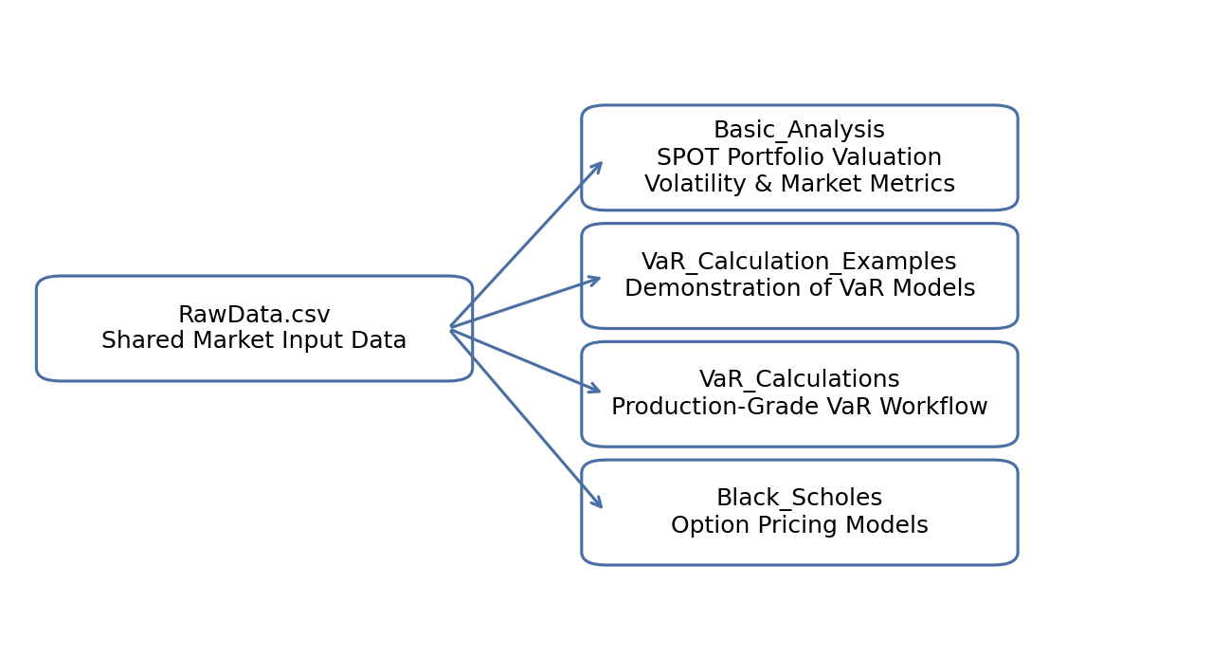
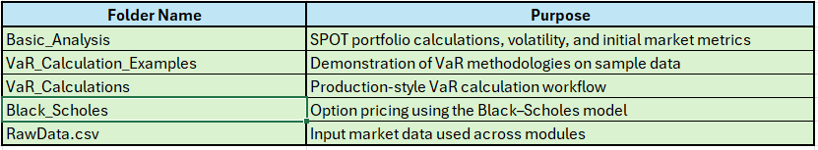

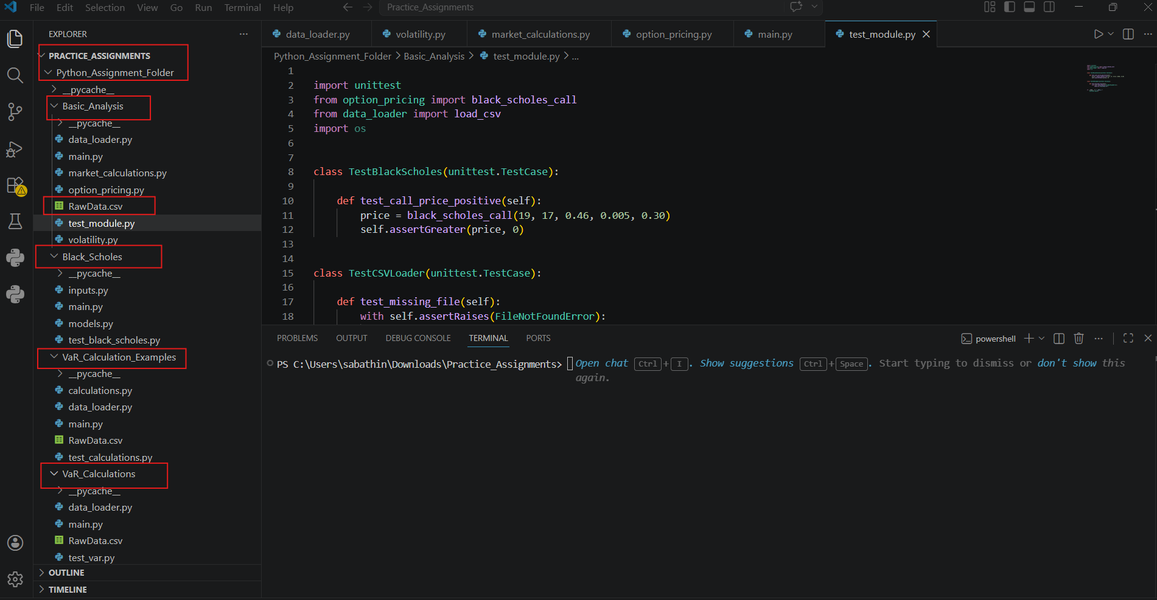

Basic Analysis Module:
Question.1 Option
Explain the difference between implied and historical volatility.
Historical Volatility (HV): Historical Volatility measures how much an asset moved in the past over a specific period.
Implied Volatility (IV): Implied Volatility is the level of volatility implied by option prices, based on an option pricing model (Ex: Black Scholes). It will tell us how volatile the market expects this stock to be.

data_loader.py
module Description: Handles loading and validation of market data
Key functions:
load_csv () – reads CSV and returns cleaned Data Frame

market_calculations.py
Module Description: SPOT value calculations
Key functions:
preprocess_data() – Cleans, formats, and prepares raw market data for SPOT value computations.

compute_log_returns() – Calculates log returns from price time series for stable and additive return analysis.

compute_shift_returns() – Computes simple returns using shifted price values to capture period‑over‑period changes.

compute_pnl() – Calculates profit and loss (PnL) based on price movements and portfolio positions.

volatility.py
Module Description: volatility estimation

Key functions:
calculate_daily_volatility() -- Computes daily price volatility based on asset return time series
calculate_annual_volatility() -- Scales daily volatility to an annualized measure using a standard trading-days assumption.

option_pricing.py
Module Description: Implements Black–Scholes call option pricing to estimate theoretical option values based on market parameters
Key functions:
black_scholes_call() – Computes the theoretical price of a European call option using the Black–Scholes formula
Workflow Description:
- Market data is loaded from CSV
- Returns are calculated
- Volatility is computed
- Results are aggregated and printed by main.py

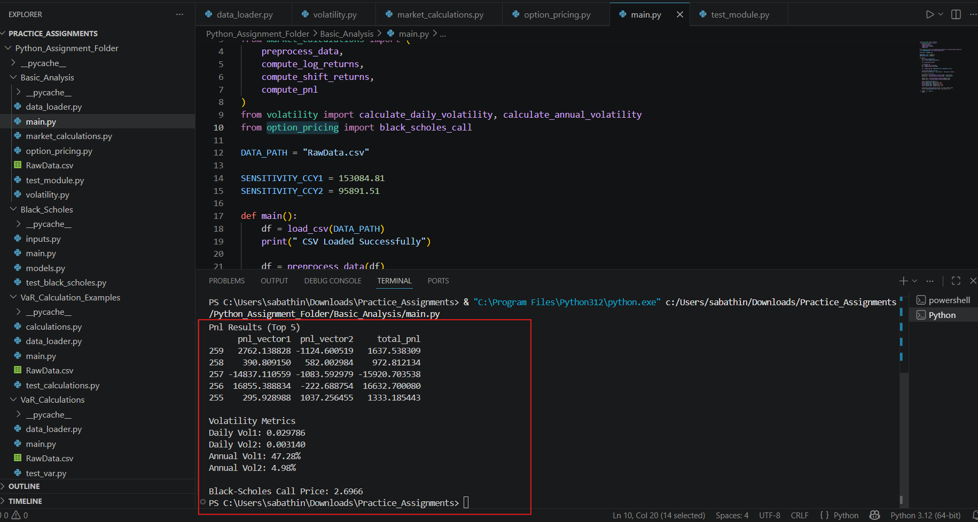
Output Results

Summary of the Output:
The output shown in the terminal represents the successful execution of your Python‑based market data analysis workflow.

It can be summarized as follows:
CSV data loading completed successfully, confirming that the input market data (RawData.csv) was read without errors.
PnL (Profit and Loss) results were computed, with the top portfolio outcomes displayed (indexed rows 255–259), showing:

Individual PnL vectors
Corresponding total PnL values
Aggregated portfolio-level metrics

Volatility estimation results were produced:
Daily Volatility (Method 1): ~0.0298
Daily Volatility (Method 2): ~0.0051
Annualized Volatility (Method 1): ~47.28%
Annualized Volatility (Method 2): ~4.98%
These reflect different calculation approaches or data transformations.

Option pricing was executed using the Black–Scholes model:
Theoretical call option price calculated as ≈ 2.70

Overall, the output confirms that data preprocessing, return calculations, PnL computation, volatility estimation, and option pricing were all executed end‑to‑end without runtime errors.

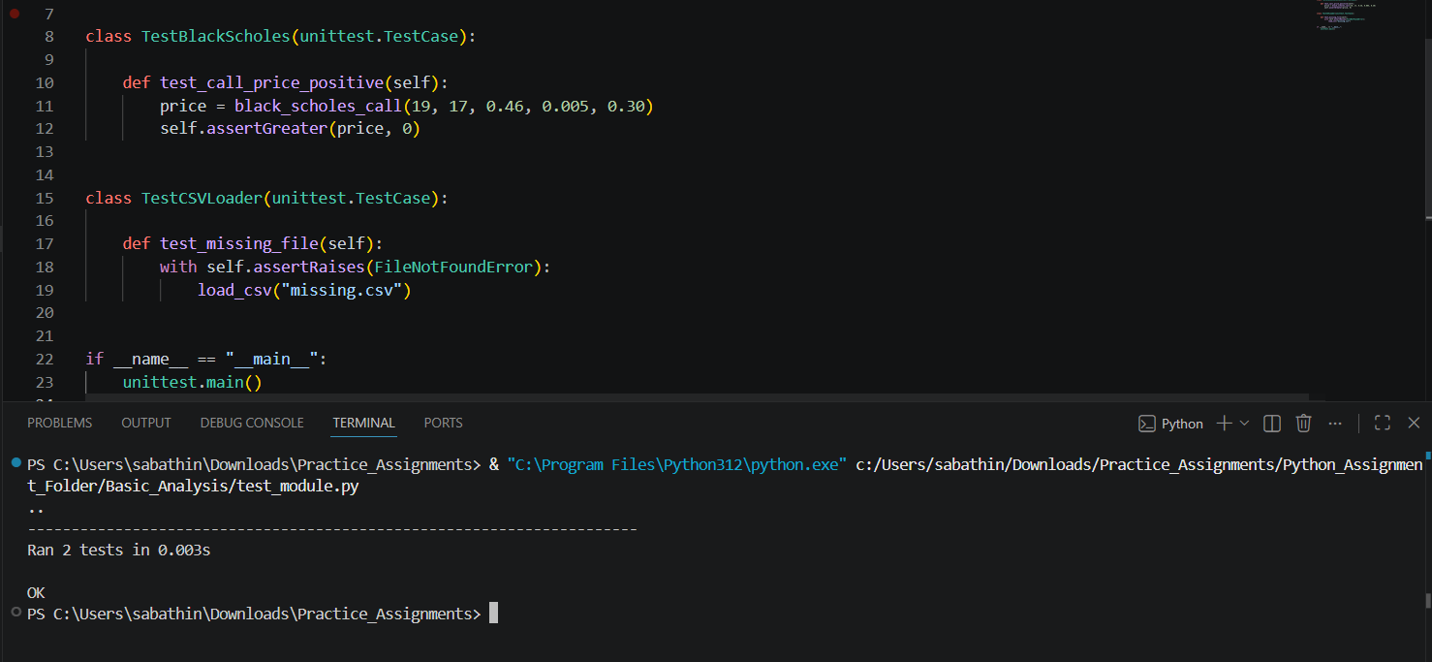
Unit tests validate that the Black–Scholes call option pricing function produces plausible (positive) values and that the CSV data loader correctly handles missing files by raising appropriate errors, ensuring both numerical correctness and robust error handling.
-----------------------------------------------------------------------------------------------------------------
Question.2 VaR
Explain VaR and list at least two calculation methods.
data_loader.py
module Description: Handles loading and validation of market data
Key functions:
load_and_prepare_data() – reads CSV and returns cleaned Data Frame

calculations.py
Module Description: SPOT value calculations
Key functions:
compute_log_returns() -- Calculates logarithmic returns from price data to measure relative price changes over time.
compute_pnl() -- Computes profit and loss based on price movements and position sizes.
historical_var() -- Estimates Value at Risk (VaR) using the empirical distribution of past returns
parametric_var() -- Calculates VaR assuming returns follow a normal distribution with estimated mean and volatility.
delta_normal_var() -- Approximates VaR using linear sensitivity (delta) and normally distributed risk factors.
monte_carlo_var() -- Estimates VaR by simulating many possible future price scenarios.
expected_shortfall() -- Measures the average loss exceeding the VaR threshold (tail risk).
gamma_var() -- Enhances VaR estimation by incorporating second-order (gamma) effects for nonlinear instruments.

Workflow Description:
- Market data is loaded from CSV
- Return & PnL Preparation
- Volatility & Distribution Estimation
- Value at Risk (VaR) Models
- Scenario-Based Risk Simulation
- Tail Risk Measurement
Output Results:
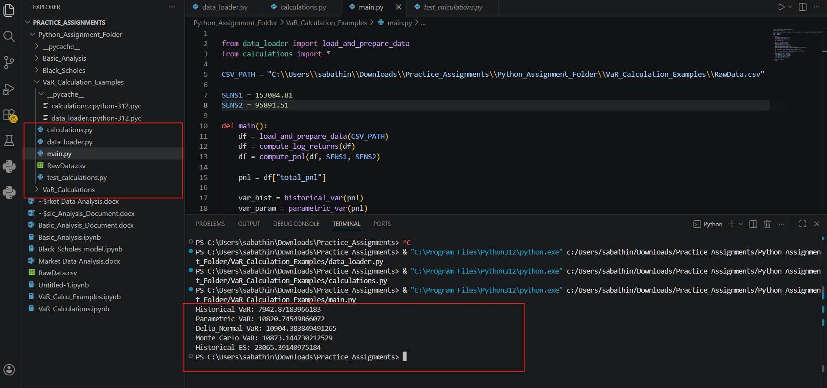

The terminal output shows the risk metrics computed for the portfolio PnL after loading data, calculating returns, and aggregating profit & loss.
- Historical VaR (~7,943)
Estimated Value at Risk based purely on past PnL observations, representing the maximum expected loss over the chosen horizon at the given confidence level.
- Parametric VaR (~10,820)
VaR calculated assuming PnL follows a normal distribution, using estimated mean and volatility higher than historical VaR due to distributional assumptions.
- Delta-Normal VaR (~10,904)
A sensitivity-based VaR using linear (delta) approximation, typically close to parametric VaR for near-linear portfolios.
- Monte Carlo VaR (~10,874)
VaR derived from simulated future PnL scenarios, capturing more realistic market dynamics than purely analytical methods.
- Historical Expected Shortfall (~23,065)
The average loss when losses exceed the VaR threshold, highlighting tail risk severity beyond worst-case expectations.
Methods that use math models or simulations assume things can go wrong in more ways than what we’ve already seen, so they estimate bigger possible losses than just looking at past data. And Expected Shortfall shows that when losses are bad, they can be much worse than the single VaR number suggests.

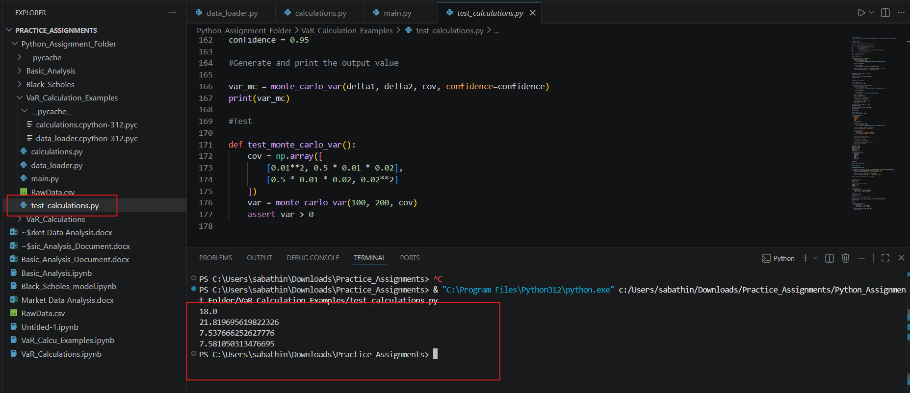
- This output confirms your Monte Carlo VaR implementation works
- It successfully estimates potential losses under uncertainty
- The test proves the model behaves sensibly and safely
------------------------------------------------------------------------------------------------------------------
Question.3 Option*
Client implemented Black Scholes model for vanilla option pricing in them excel spreadsheet based on the formulas in the screenshots, (assuming zero dividends).
Implement the model** in python code and validate/test the model for Call and Put options.
- test for in the money, at-the-money, out-of-money with attention to unit and end-to-end testing
- **Feel free to choose any method for model implementation, either with forward price or with spot price or with put-call parity

inputs.py
Module description: Defines all market data, dates, derived parameters, and test scenarios required for Black-Scholes pricing and validation.
model.py
Module Description: Implements analytical Black-Scholes formulas, Greeks, forward pricing, put-call parity and Monte Carlo valuation functions.
Key Functions:
- forward_price() – Computes the forward price from spot using continuous compounding and dividend yield.
- d1_spot () – Calculates the Black-Scholes d1 parameter using the spot price.
- d2_from_d1() – Computes d2 directly from d1 and volatility.
- d1_forward () – Computes d1 sing the forward price formulation.
- call_spot () – Prices a European call option using the spot-based Black-Scholes formula.
- put_spot () – Prices a European put option using the spot-based Black-Scholes formula.
- call_forward () – Prices a European call option using the forward-measure Black-Scholes formula.
- delta_call () – Computes the call option Delta sensitivity with respect to spot price.
- delta_put () – Computes the put option Delta sensitivity with respect to spot price.
- gamma () – Computes the Gamma sensitivity measuring curvature of option price vs spot.
- Vega () – Computes the Vega sensitivity measuring option price response to volatility.
- mc_call () – Estimates the European call price using Monte Carlo simulation.
- mc_put ()– Estimates the European put price using Monte Carlo simulation.

main.py
Module Description: Acts as the execution driver that runs pricing, Greeks computation, and validation scenarios.
Key Functions:
- run_base_case () – Executes pricing and Greeks for the base market parameters.
- run_itm_atm_otm () – Runs pricing scenarios for in-the-money, at-the-money, and out-of-the-money spots.
- run_mc_validation () – Compares Monte Carlo prices against analytical Black-Scholes results.

test_black_scholes.py

Module Description: Contains unit tests validating correctness, financial consistency, and numerical stability of the model.
Test Functions:
- spot_price_positive () – Verifies option prices are non-negative for positive spot values.
- spot_equals_strike () – Confirms correct pricing behavior when spot equals strike.
- spot_deep_in_the_money () – Validates pricing limits for deep in-the-money options.
- spot_out_of_the_money () – Verifies near-zero values for far out-of-the-money options.
- forward_price_from_spot () – Checks consistency between spot and forward price formulations.
- spot_at_expiry () – Validates option payoff behavior as time to maturity approaches zero.
- spot_price_increase () – Ensures monotonic increase of call price with increasing spot.
- test_put_call_parity () – Verifies analytical put-call parity holds numerically.
- test_forward_vs_spot () – Confirms equivalence of forward-based and spot-based pricing.
- test_greeks_bounds () – Ensures Greeks fall within known theoretical bounds.
- test_mc_convergence () – Verifies Monte Carlo prices converge to analytical values.
- output_greeks_bounds () – Reports Greeks boundary values for diagnostic and validation purposes.
Output Results:
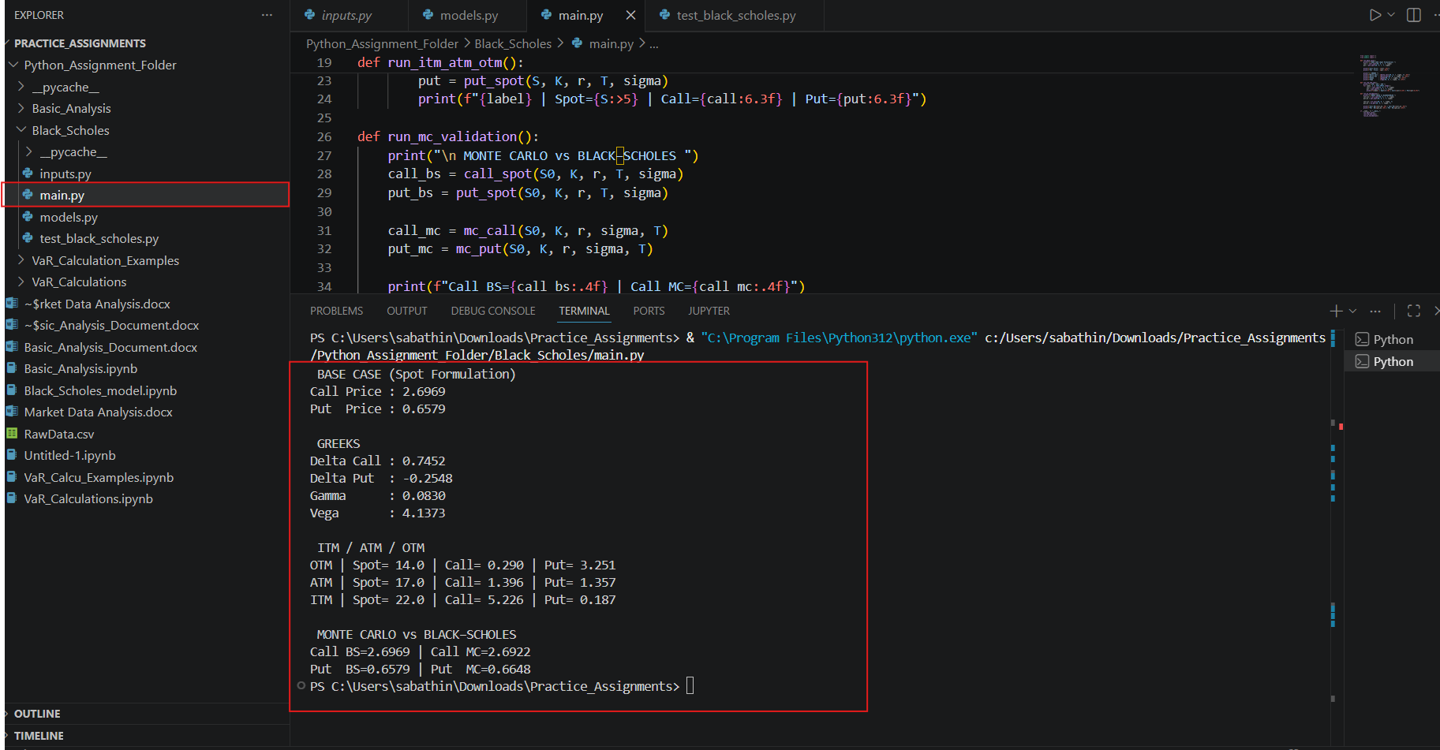

From the screenshot we can notice that
Base Case (Spot formulation):
- Call price ≈ 2.697
- Put price ≈ 0.658
Greeks (sensitivities):
- Call Delta ≈ 0.745
- Put Delta ≈ −0.255
- Gamma ≈ 0.083
- Vega ≈ 4.137
Moneyness analysis (ITM / ATM / OTM):
- OTM (Spot 14): Low call value, high put value
- ATM (Spot 17): Balanced call and put values
- ITM (Spot 22): High call value, low put value
Results show correct monotonic behavior with respect to spot price.
Monte Carlo validation:
- Monte Carlo prices for both call and put closely match analytical Black-Scholes prices.
- Confirms correctness and convergence of the Monte Carlo implementation.
The output demonstrates a correct, well-structured Black-Scholes implementation, validating:
- Analytical pricing
- Greeks’ computation
- Spot vs forward consistency
- Monte Carlo convergence
------------------------------------------------------------------------------------------------------------------
Question.4 VaR*
Bank has FX portfolio consisting of two currencies. Risk manager implemented historical VaR methodology as defined in internal policies (1 day with .99 confidence level) for the FX portfolio in excel, assuming no correlation between these currencies.
- implement the VaR calculation in python to revert one day VaR value
One year of historical data (market rate) for the currencies and current/spot portfolio value is known.
File Name: load_csv_data.py
Module Description: Loads and validates market data from CSV files for VaR calculations.
Key Function:
- load_csv_data() – Reads CSV market data into a structured pandas Data Frame with basic validation.
File Name: VaR_Calculation.py
Module Description: Provides core financial computations for returns, profit and loss, and historical Value at Risk.
Key Functions:
- compute_market_returns () – Calculates periodic market returns from a series of asset prices.
- compute_pnl () – Computes profit and loss based on market returns and portfolio positions.
- calculate_historical_var () – Estimates historical Value at Risk using the empirical PnL distribution.

File Name: main.py
Module Description: Orchestrates data loading and VaR calculations to produce final risk metrics.
Key Function:
- calculate_historical_var () – Executes the end-to-end workflow to compute historical VaR from raw market data.
File Name: test_VaR.py
Module Description: Contains unit tests to validate market returns, PnL calculations, and VaR output.
Key Test Functions:
- test_market_returns – Verifies correctness of market return calculations.
- test_pnl_calculation – Ensures PnL computation logic produces expected results.
- test_var_output – Validates that historical VaR output matches expected risk thresholds.

Output Results:
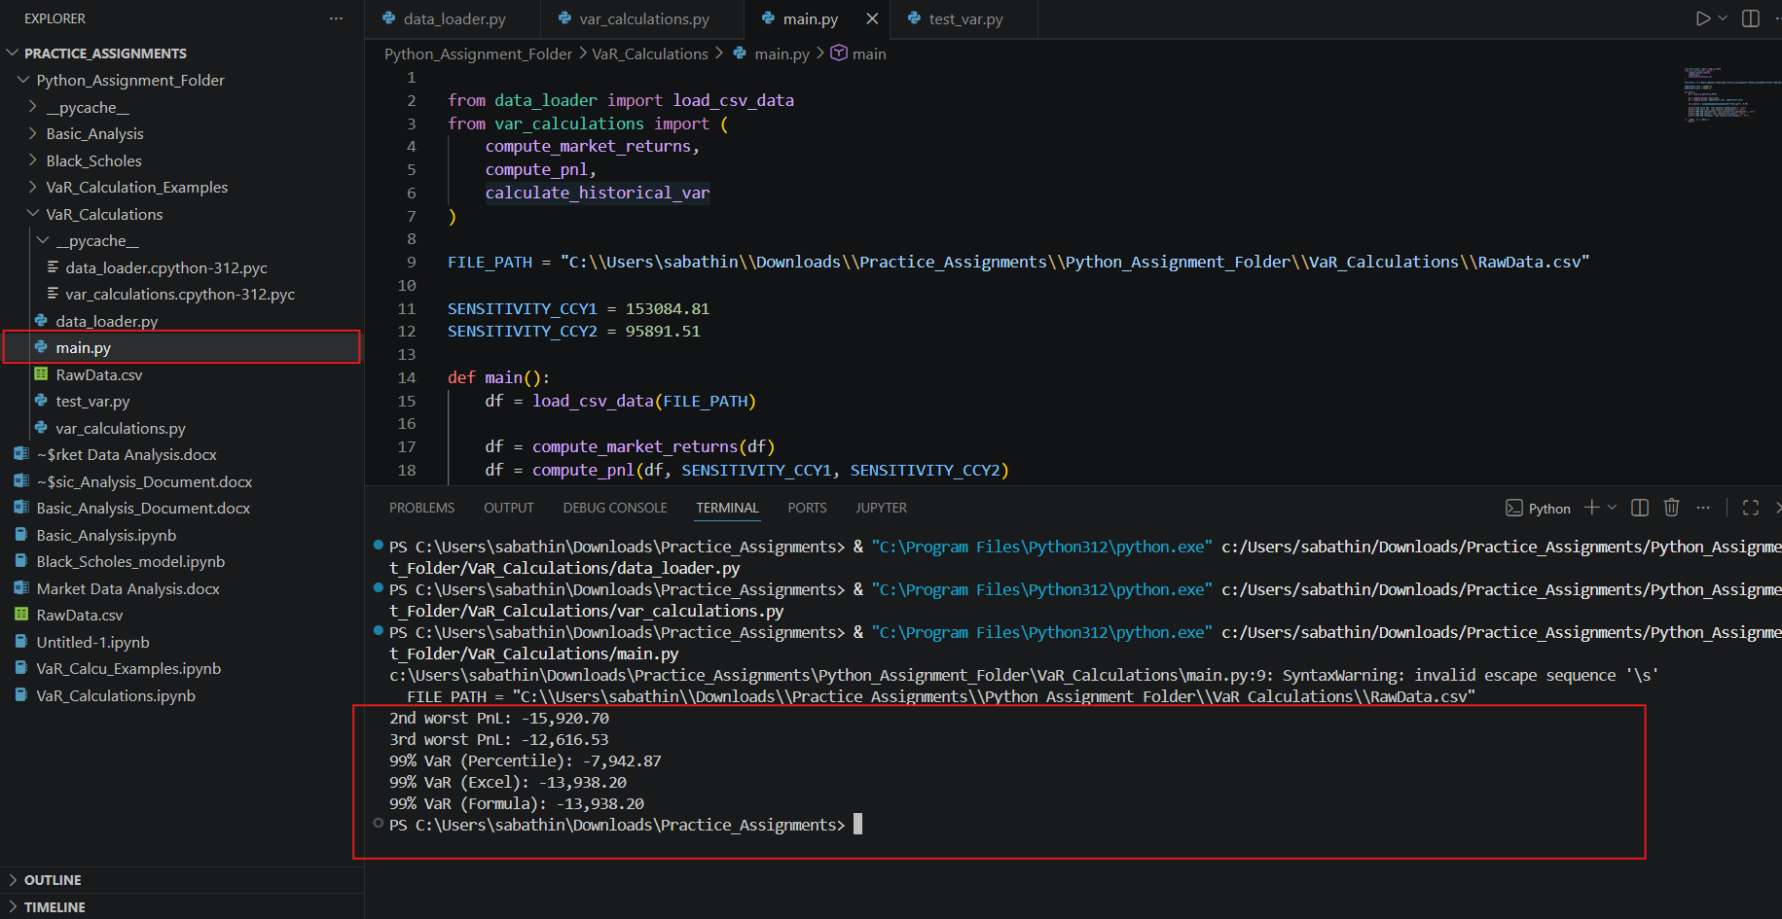

- 2nd Worst PnL (-15,920.70): Represents the second-largest historical portfolio loss, highlighting severe downside risk just below the worst-case scenario.
- 3rd Worst PnL (12,616.53): Indicates another extreme loss event, confirming that significant portfolio losses occur more than once in the data.
- 99% VaR (Percentile Method: -7,942.87): Indicates that 99% of historical outcomes show losses smaller than 7,942.87, using a direct empirical percentile approach.
- 99% VaR (Excel Method: -13,938.20): Provides a more conservative 99% risk estimate by interpolating between tail losses in the PnL distribution.
- 99% VaR (Formula Method: -13,938.20): Matches the Excel method result, confirming the correctness and consistency of the VaR calculation logic.

Conclusion:
Overall, the results show that the portfolio can suffer large losses during extreme market conditions, and the 99% VaR methods that use interpolation give a more accurate and dependable estimate of these potential extreme losses than the basic percentile method.

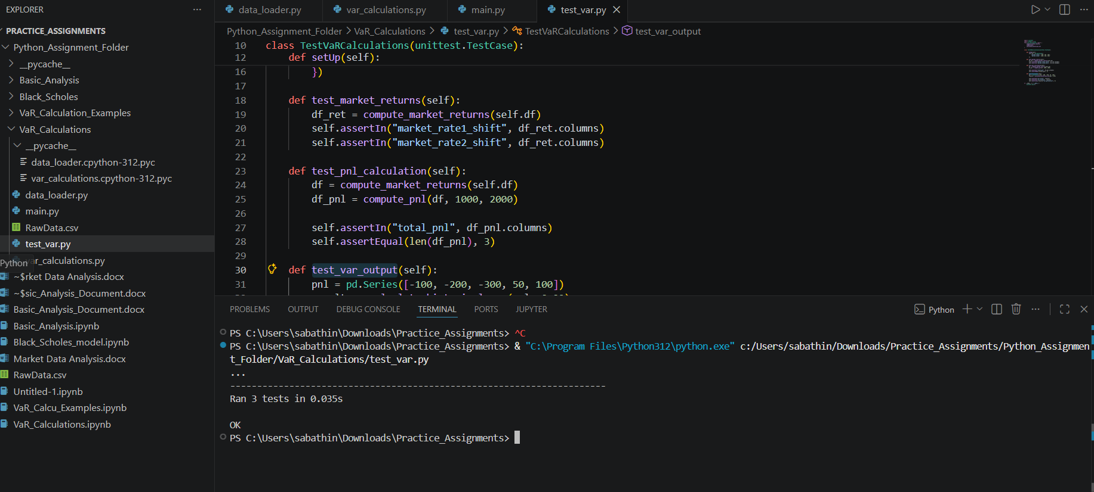
All three tests pass without errors, confirming that the VaR computation logic and supporting functions work as expected.
This assessment successfully demonstrates the correct implementation of data loading, market return computation, profit-and-loss calculation, and historical Value at Risk estimation, supported by passing unit tests that validate the accuracy, robustness, and reliability of the overall solution.

